
 | 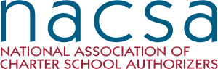 | 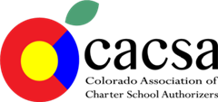 |  | 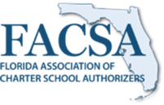 | 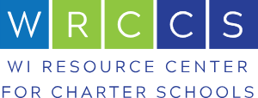 | 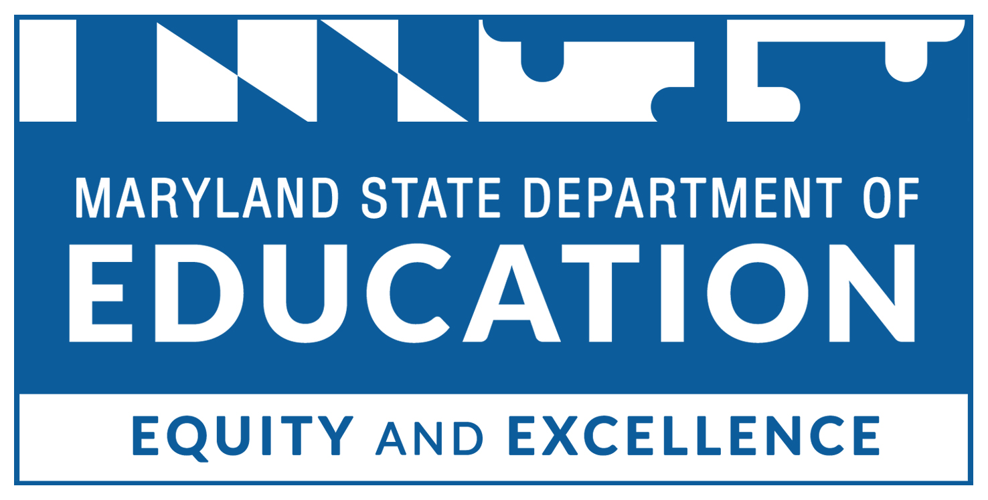
Model Resource | NACSA | CACSA Resource Library | CCAP Resource Library | FACSA Resource Library | Wisconsin Resource Library | Maryland Resource Library | Oklahoma Resource Library
Initial Application Resources
Application |  | Resource Library Link for Application Materials  2020 Revised Standard Application | Petition Toolkit for New School | Florida DOE Resources for authorizers  Florida Application Review Training Materials  Charter Review Team Training Template | Wisconsin Resource Center Model Application Process | Anne Arundel How to Start a Charter School  Arundel Application  Baltimore City New Application  Baltimore City New Application Forms
Application Rubric |  | 2020 Revised Application Rubric | Evaluation rubric |  |  | Baltimore City New School Rubric | Application Rubric
Virtual School Application
Virtual School Rubric
Capacity Interviews |  | Capacity Interviews and Review Process and model tools |  | FACSA Capacity Interview Protocol for Students with Disabilities Issues  Duval County PUblic Schools Capacity Interview (Deck)
Contract Resources
Model Contracts |  | Resource Library Link for Contracts  2022 Revised Model Contract  Denver Public Schools Single Site Contract  Caplan & Earnest Contrac  t  CACSA Side-by-Side Contract Analysis | CCAP MOU Resource |  | Model Contract  Virtual School Model Contract |  | Model Contract V 1  Model Contract V2  Contract Checklist
Annual Reports
Annual Report Template and Rubrics | Performance Framework | Resource Library for Annual Reports  Annual Report Overview  CACSA 2020 Report Template  Annual Report Mock up Emphasizing Academic Performance  Annual Report Mock Up Emphasizing Overall Performance  2020 Denver Public Schools  Charter Schools Institute Financial Framework  District 49 Report Template | Annual Report Toolkit Intro  Annual Report Toolkit  Financial Annual Report  Operations Annual Report | Annual Report Template (word doc)  Annual Report and Rubric  Annual Report and Rubric: Deck | Annual Report Template  Appleton Example  Annual Reporting Calendar
Annual Site Visit Template |  | Aurora Public Schools Site Visit Report | Annual Site Visit Protocol | 21-22 Site Visit Template Hillsborough County |  | Anne Arundel Site Visit  Performance Management
Annual Site Visit Rubric |  | 2020 Site Visit Rubric  Training on Site Visit Rubric  DPS Quality Schools Review  Rubric  CSI Cars Handbook |  | 21-22 Site Visit Rating Rubric Hillsborough County
Renewal Resources
Renewal Guides and Templates |  | Resource Library for Renewal  Charter Renewal Guide |  | Florida Renewal Template  21 Polk County Renewal App Part I  21 Polk County Renewal App Part II |  | Anne Arundel Renewal Application  Baltimore City Renewal
Contract Renewal Checklist |  | Charter School Institute Renewal Requirements  CSI Renewal Handbook | Renewal Action Plan | 21-22 Renewal Review Criteria Checklist Hillsborough County  FACSA Deck on Contract Modification and Amendment  Website Audit Checklist |  | Baltimore City Renewal Rubric
Renewal Review Rubric |  |  |  | 21-22 Contract Renewal Review Rubric Hillsborough County
Year O and Opening Resources
Opening Checklist |  |  |  | Opening Checklist  Pre-opening Checklist - Duval County  Pre-opening Checklist - Miami Dade County |  |  | Startup Checklist
Year 0 Guidance |  | Resource Library for Year 0 Guidance  CSI Year 0 Guidance  DPS Year 0 Guidance |  | Authorizer Guide to Year 0
Miscellaneous Resources
District Coop Contract
Compliance calendar
Corrective Action Plan
Special Populations
Resource Libraries for Special Populations | NACSA & CLE Tool Kit for Special Education | CACSA Equity Resources
Needs Assessment |  |  |  | Needs Assessment to Improve Access and Services for Students with Disabilities
Capacity Interviews |  |  |  | FACSA Capacity Interview Protocol for Students with Disabilities Issues
Improving school communications |  | Promoting Access & Choice Through Inclusive Language (deck)  Promoting Access & Choice Through Inclusive Language (document)  Website Language for Charter Schools on Students with Disabilities  School Self Assessment for Special Education Enrollment
Contract Negotiation Considerations |  | CSI Special Education MOU |  | Florida Charter School Contract Negotiations: District Considerations for Exceptional Student Education
Annual Report to schools on equity and services |  | Charter School Institute Student Services Screener (Annotated)

